A Project Report On

**FINGERPRINT AUTHENTICATION FOR ANDROID APPLICATION**

Submitted by

|  |  |
| --- | --- |
| **AJMAL KHAN** | **SS15CO015** |
| **ATUL HANDGAR** | **SS16COO46** |
| **ANAGHA SHAH** | **SS16COO57** |
| **SNEHA TAMBE** | **SS16COO42** |
| **FIZA FARIDI** | **SS16CO043** |

**For**

**Diploma in Computer Engineering**

**2018-19**

Under the guidance of

**Prof. POOJA S. CHAME**



**Department of Computer Engineering**

**Government Polytechnic, Mumbai**

**Mumbai-400051**



**Department of computer engineering**

**GOVERNMENT POLYTECHNIC, MUMBAI**

Mumbai-400051

Certificate

This is to certify that following students have successfully and satisfactorily completed the coursework for Project and Seminar- II on **FINGERPRINT AUTHENTICATION FOR ANDROID APPLICATION** and presented their report for Diploma in Computer Engineering from Government Polytechnic, Mumbai under the guidance of **Prof. POOJA S. CHAME** in the academic year 2018-2019.

|  |  |  |  |
| --- | --- | --- | --- |
|  |  | **AJMAL KHAN** | **SS15CO015** |
|  |  | **ATUL HANDGAR** | **SS16CO046** |
|  |  | **ANAGHA SHAH** | **SS16CO057** |
|  |  | **SNEHA TAMBE** | **SS16CO042** |
|  |  | **FIZA FARIDI** | **SS16CO043** |

|  |  |  |
| --- | --- | --- |
| Project Guide |  | External Examiner |
| Head of the department |  | Principal |

Acknowledgement

We are profoundly grateful to **Prof. V.M. ASWAR AND Prof. POOJA S. CHAME** for her expert guidance and continuous encouragement thoughtful to see that this project rights its target since its commencement to its completion.

We would like to express deepest appreciation towards **Prof. SWATI DESHPANDE,** Principal, Government Polytechnic Mumbai, **Prof. V.M. ASWAR**, Head of Department of Computer Engineering and **Prof. POOJA S. CHAME** Projector Coordinator whose invaluable guidance supported us in completing this project.

At last we must express our since heartfelt gratitude to all the staff members of Computer Engineering Department who helped us directly or indirectly during this course of work.

|  |  |
| --- | --- |
|  | **AJMAL KHAN**  **SS15CO015** |
|  | **ATUL HANDGAR**  **SS16CO046** |
|  | **ANAGHA SHAH**  **SS16CO057** |
|  | **SNEHA TAMBE**  **SS16CO042** |
|  | **FIZA FARIDI**  **SS16CO043** |

Abstract

We are developing an android application **(QUICKPAY)** for Shopping, Movie and Event tickets. This application has the feature of fingerprint login authentication. The user have to register/sign up with their fingerprint, after registration the user can login or sign in using that registered fingerprint.

You can buy different types of products through this application. You are able to purchase mobile phone and related accessories, computer accessories, cloths, and much more.

**Let’s have a look at the 10 reasons that makes fingerprint authentication so popular:**

1. One of the most developed biometrics
2. No two finger have the exact same dermal ridge characteristics
3. It does not change age or get affected by any disease.
4. Small storage space required for the biometric template
5. It can’t be lost, shared and duplicated
6. Extremely quick, one can be identified or rejected in a matter of seconds
7. Easy to use, requires no additional training
8. Create a centralized or decentralized solution to meet your needs
9. Leaves a clear, definable audit trail of transactions or activities
10. Reduces the amount of human work

**Table of Contents**

1. Introduction 1

1.1 Basic Idea 2

1.2 Statement of Problem 2

2.Literature Review **3**

2.1 Background 4

2.2 Referred Concept 4

2.3 Existing System 5

2.4 Proposed System 5

3. Requirement Analysis 6

3.1 Hardware Requirements 7

3.2 Software Requirement 7

3.2.1 front-end 7

3.2.1 back-end 7

3.3 Feasibility Study 8

3.3.1 Operational Feasibility 8

3.3.2 Economical Feasibility 8

3.3.3 Technical Feasibility 8

4. System Design 9

4.1 Modeling Diagrams 10

4.2 Algorithm 11

4.3 FLOWCHARTS 11

4.4 Database Structure 12

5. Implementation 16

5.1 Android 17

5.2 Website 17

6. Coding Output and Screenshots 19

7. Testing 32

7.1 Black Box Testing 33

7.2 Unit Testing 34

8. Conclusion 35

9. Future Scope 37

10. Bibliography and Reference 39

**List of Figures**

Fig 1 - 1 Quickpay verify user activity 4

Fig-2 Quickpay fingerprint authentication 4

Fig-3 000webhost.com/filemanage 17

Fig -4 Firebase database 18

Fig-5 Quickpay shopping 10

Fig-6 Login flowchart 11

Fig-7 000webhost manage database 12

Fig-8 Registration table 12

Fig-9 Firebase home 13

Fig-10 New product document 13

Fig-11 Popular product documents 14

Fig-12 Mobile documents 14

Fig-13 Headphone 15

Fig-14 Laptop documents 15

Fig-15 Register 27

Fig-16 Verify user 27

Fig-17 Fingerprint authentication 28

Fig-18 Home activity 28

Fig-19 Categories 29

Fig-20 Mobile categories 29

Fig-21 Product details 30

Fig-22 Fragments 30

Fig-23 Profile 31

Fig-24 Contact 31

CHAPTER 1

INTRODUCTION

## 1. Introduction

## Basic Idea

The idea behind this application is to provide the security and fast access . The fingerprint authentication is particularly easy for users to present their biometrics for scanning. It does not make user conscious, just a casual scan and you are done. Login with fingerprint is very fast and quick.

## Statement of Problem

The Android application used email, username, password and other personal information for register with the application.

It takes more time to sign in/ login with username and password. It often happens that the user are no longer remember the password.

The password can be easily hackable.

Chapter 2

**Literature Review**

## Literature Review

## 2.1 Background

Fingerprint Authentication is used in the QUICKPAY application before application get started. This technique helps to protect any data related with the user. Fingerprint is one of the most development biometric technique and easy to use.

## 2.2 Referred Concept

FIG 1 QUICKPAY VERIFY USER FIG 2 : QUICKPAY FINGERPRINT

**ACTIVITY** AUTHENTICATION

## 2.3 Existing System

In existing application user have to register with username and password and after sign up user have to enter registered username and password for log in, which increases the cost of time.

Also Sometime user forgot/lost their password and unable to login into the application. Passwords and tokens are easy to hack.

## 2.4 PROPOSED SYSTEM

The purpose to develop this application is to reduce the amount of time it takes while sign up or login. We are using fingerprint authentication for login, which is very fast and secure.

Fingerprint is one of the most developed biometric, It can’t be lost, shared and duplicated. It is extremely quick.

Chapter 3

Requirement Analysis

# Requirement Analysis

## Hardware Requirements

Your development workstation should meet or exceed these hardware requirements:

* Microsoft Windows 7/8/10 (32 or 64 bit)
* 4 GB RAM minimum, 8 GB RAM recommended
* 2 GB of available disk space minimum

## 3.2 Software Requirement s

The application is supported for all the smartphones having android 5.1.0 and above.

Below are the software we required to build the application

### 3.2.1 Front-End

The software required to design the user interface and user experience i.e.: front end are given below

1. Android studio: it is a platform provided by Google to make android application.it mainly supports java programming language .java is the main programing language used.
2. XML : this is used to design the user interface of the application
3. Notepad++ : for validation in PHP files.

### 3.2.1 Back-End

1. MySQL : To verify user before login we are using MySQL database. The main backend technology is used for storing and managing databases is a MYSQL that provides online database storage options along with “phpmyadmin.” SQL is the programing language used for backend.

2. Firebase Database : To Store user and product details we are using firebase database.

## 3.3 Feasibility Study

The basic idea behind feasibility study is to determine whether the project is feasible or not. Feasibility is conducted to identify a best system that meets all the requirements. This includes an identification, description, an evaluation of the proposed systems and selection of the best system for the job.

### 3.3.1 Operational Feasibility

This systems provide more accurate identification, lowering your risk of unwanted breaches. With this type of security system, access is granted not by passwords or smart cards but by biological characteristics like fingerprints which are difficult to duplicate or forge.

### 3.3.2 Economical Feasibility

In this investigation we go thorough deciding budget and cost for developing our project. As it is an android application it requires less resource than other real life products hence the outcome of this study was fairly simple and beneficial for us

### 3.3.3 Technical Feasibility

The main consideration is to be given to the study of available resources of the organization where the software is to be implemented.

Chapter 4

System Design

# System Design

System design is the process of defining the architecture, modules, interfaces, and data for a system to satisfy specified requirements. System design could be seen as the application systems theory to product development.

## Modeling Diagrams

Draw all UML Diagrams if you have decided to follow any Object Oriented Language for the Project Implementation.

## Use Case Diagram

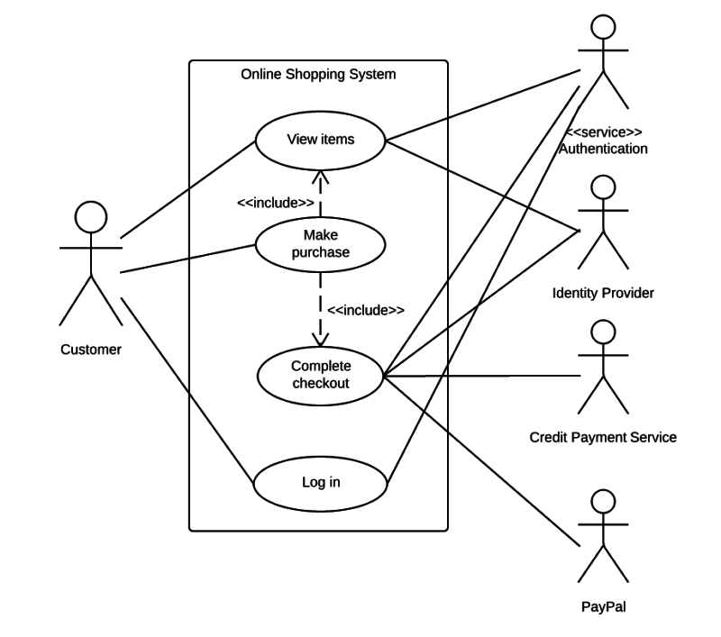

FIG 5 : QUICKPAY SHOPPING

## 4.2 Algorithm

Below are steps given to describe how the login processes in form of algorithm does.

Steps:

1. Start
2. Enter username
3. Server check username if match not found go to step 2.
4. Place your fingerprint
5. User already exit go to step 2.
6. Stop

## FLOWCHARTS

In the give flowchart (fig 6) it is shown that how a user request for a service and then the blink processes that request to authority server. Authority serve send nonfiction to service person and if he respond then authority servers notifies it to the user through the application. In case the service person does not responds the authority server can send request to another service persons too.

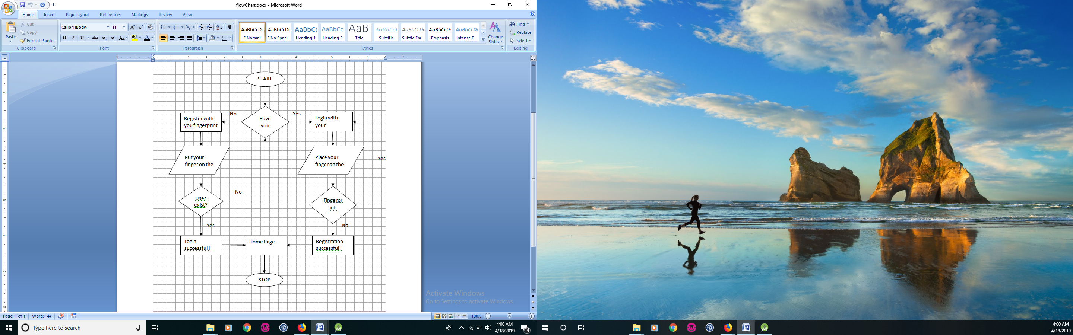

FIG-6 LOGIN FLOWCHART

## 4.4 Database Structure

We have used following Database for our application :

1. 000webhost : For Registration and Login purpose only

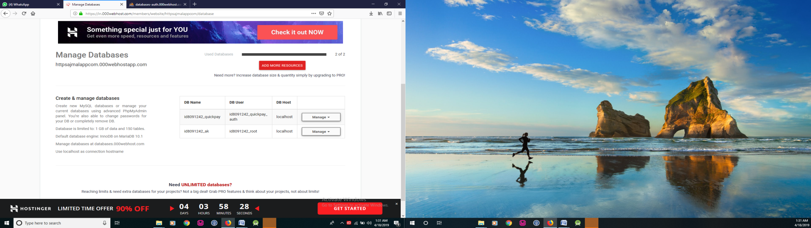

FIG-7 000webhost MANAGE DATABASE

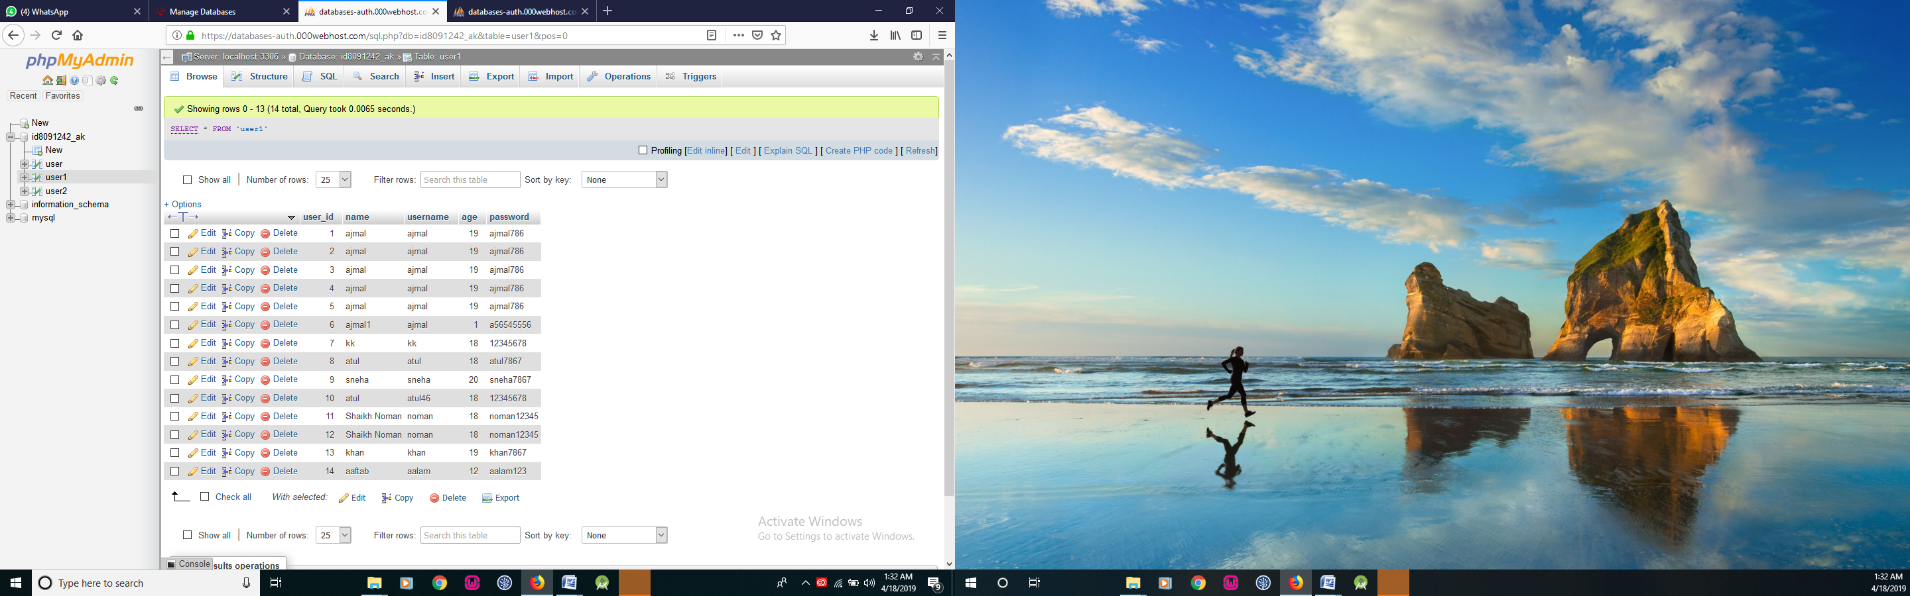

FIG-8 REGISTRATION TABLE

1. Firebase Database : For order related details

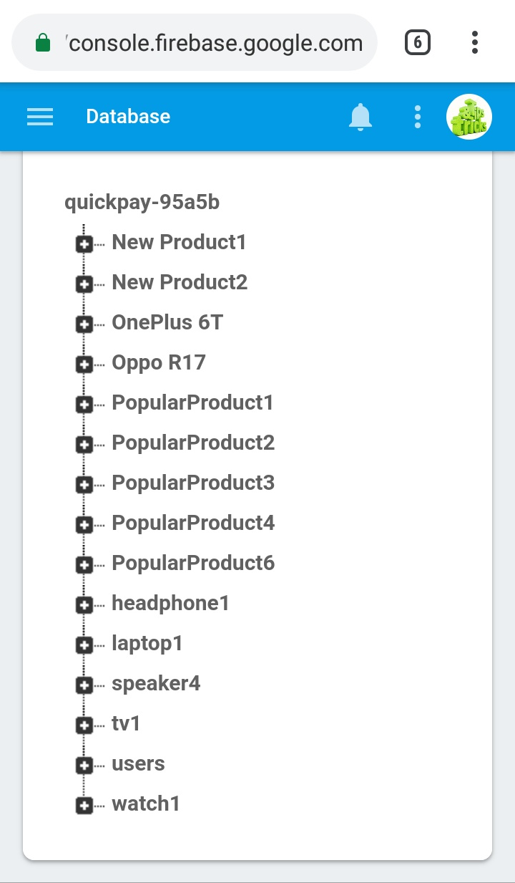 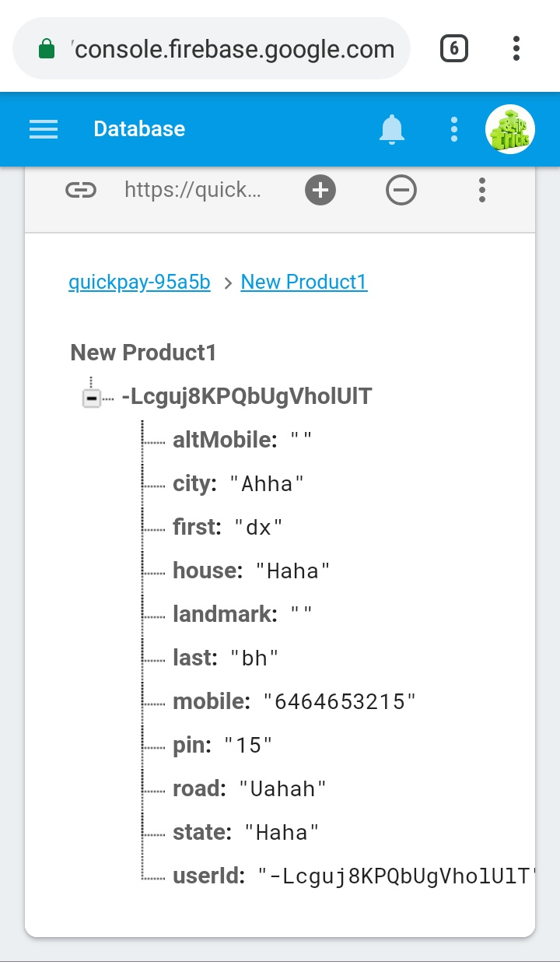

FIG-9 FIREBASE HOME FIG-10 NEW RPDUCT

DOCUMENT

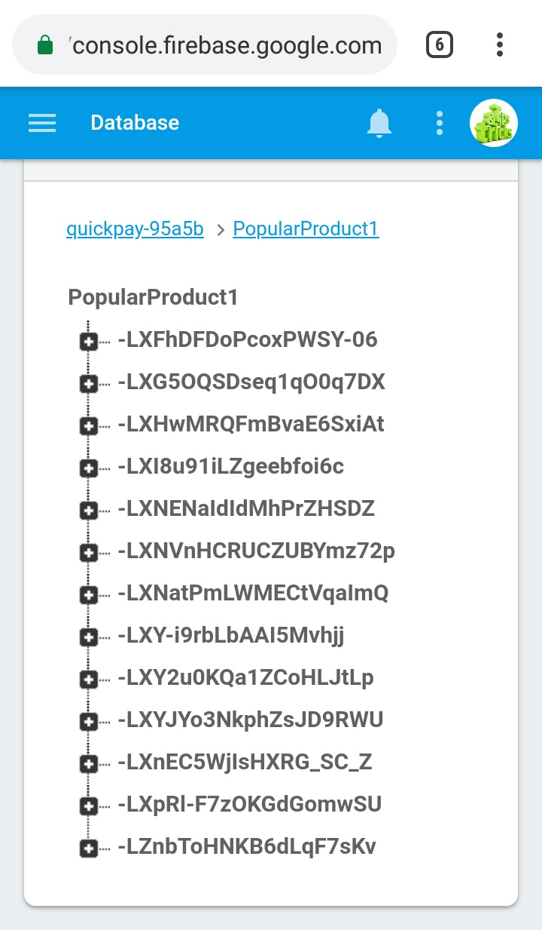 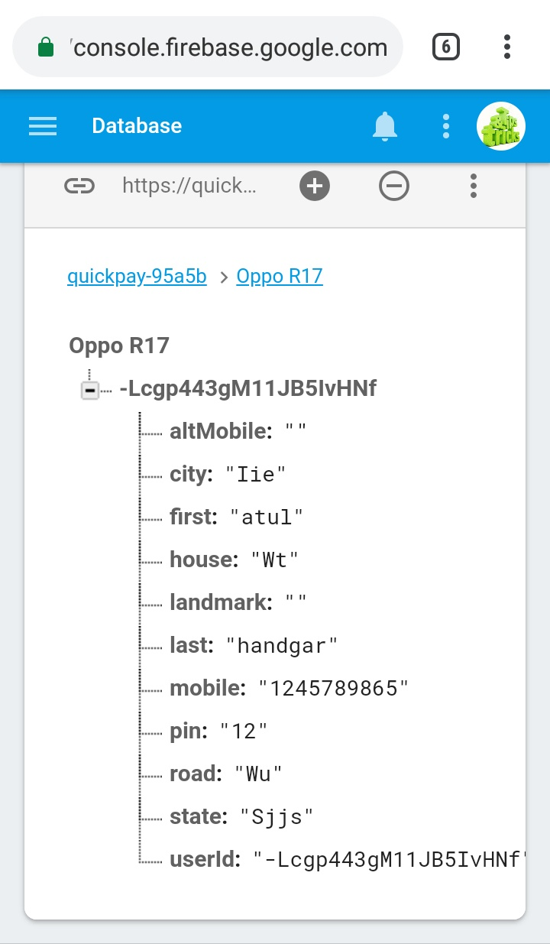

FIG-11 POPULAR PRODUCTS FIG-12 MOBILE DOCUMENTS

**DOCUMENTS**

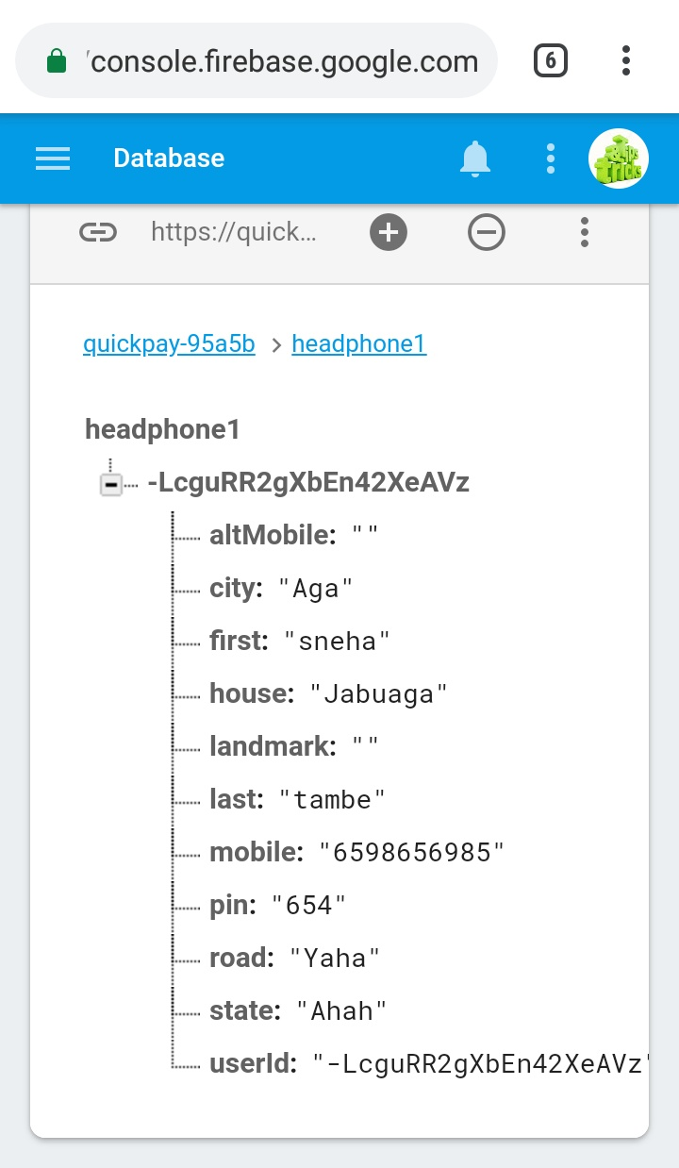 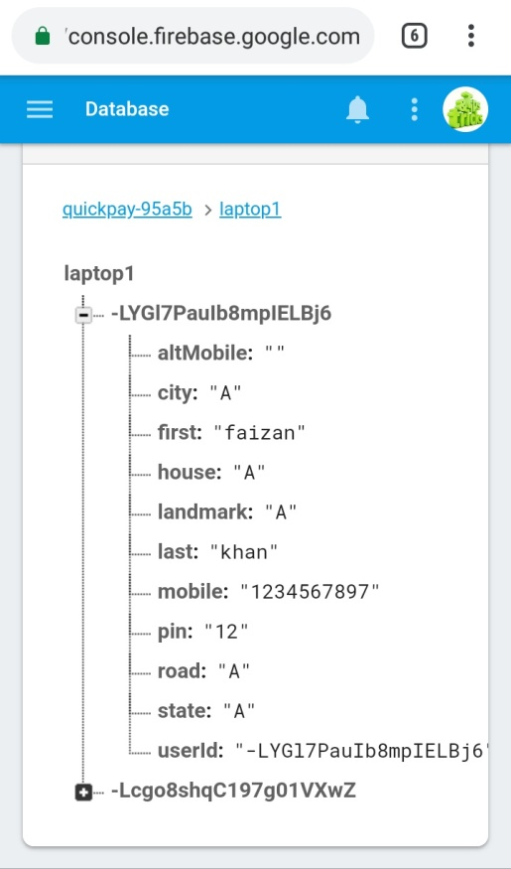

FIG-13 HEADPHONE FIG-14 LAPTOP DOCUMENTS

Chapter 5

Implementation

1. **Implementation**

**5.1 Android**

We have used Android Studio for our project;

We have done all our implementation of software processing on Android Studio.

We have developed the application using these following platforms:

1. Android Studio
2. MySQL

**5.2 Website.**

We have used following webhost for our application :

1. 000webhost : For Registration and Login purpose only

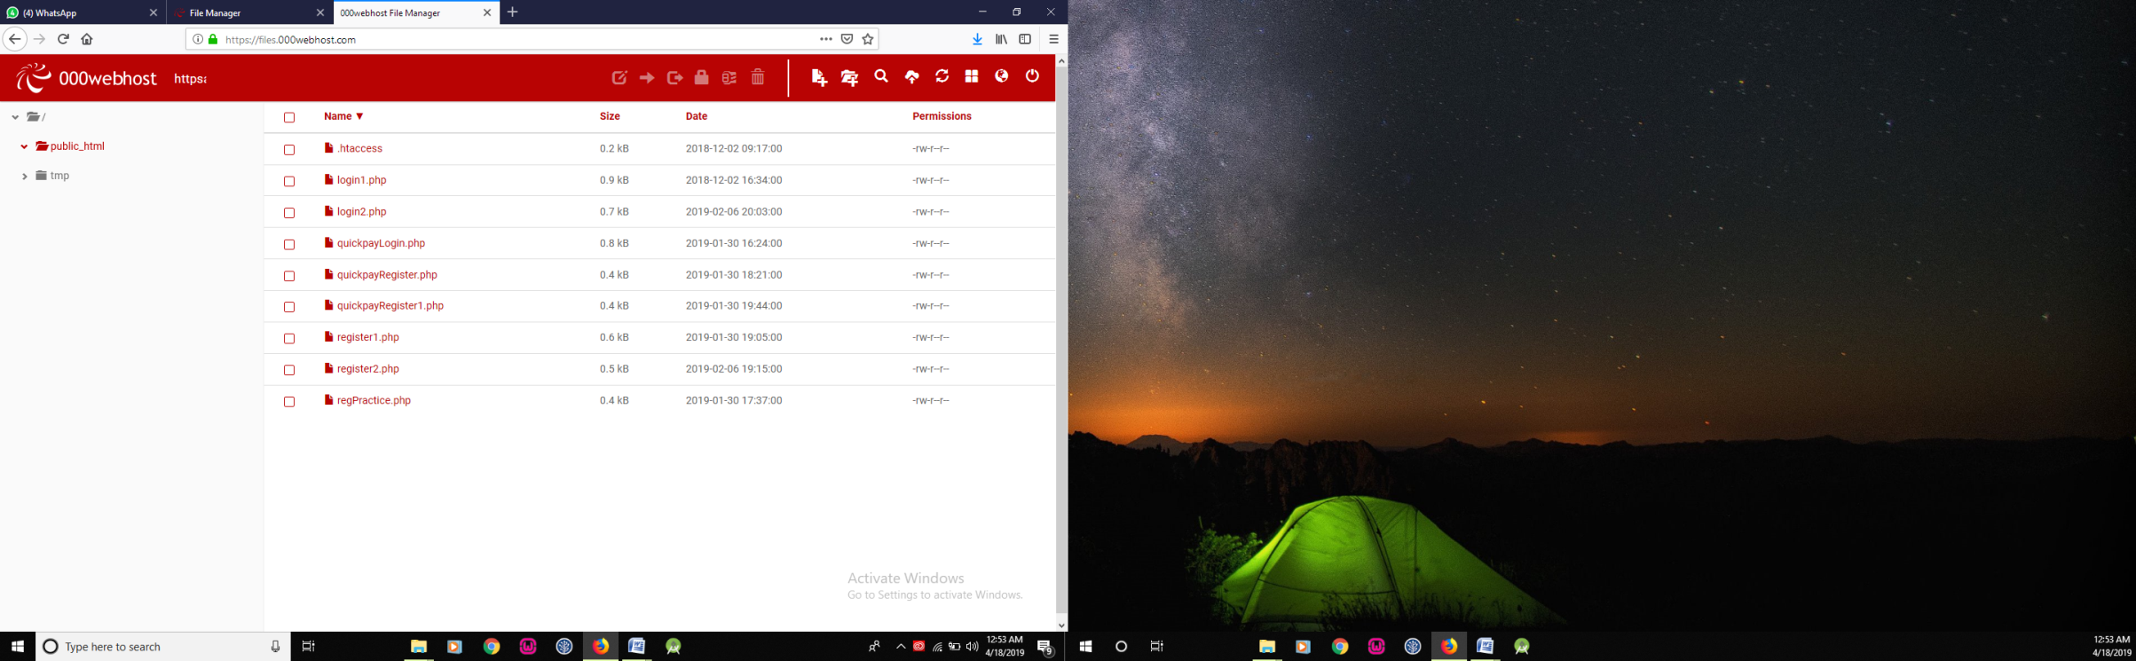

FIG 3 : 000webhost.com/file manage

1. Firebase Database : For order related details

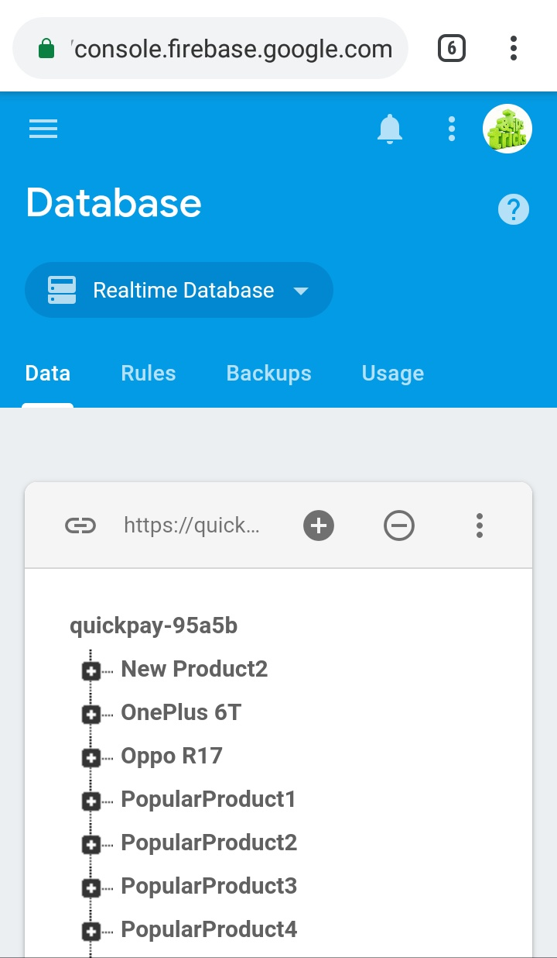

FIG 4 : Firebase Database

Chapter 6

Coding Output and Screenshot

**Coding :**

**RegisterActivity** (For new user) :

**package** com.ak.test;  
  
**import** android.app.ProgressDialog;  
**import** android.content.Intent;  
**import** android.os.Bundle;  
**import** android.support.v7.app.AlertDialog;  
**import** android.support.v7.app.AppCompatActivity;  
**import** android.view.View;  
**import** android.widget.Button;  
**import** android.widget.EditText;  
**import** android.widget.TextView;  
**import** android.widget.Toast;  
  
**import** com.ak.test.R;  
**import** com.android.volley.RequestQueue;  
**import** com.android.volley.Response;  
**import** com.android.volley.toolbox.Volley;  
  
**import** org.json.JSONException;  
**import** org.json.JSONObject;  
  
**public class** RegisterActivity **extends** AppCompatActivity {  
 Boolean **isValidationSuccessFull** = **true**;  
 **private** EditText **etAge**;  
 **private** EditText **etName**;  
 **private** EditText **etUsername**;  
 **private** EditText **etPassword**;  
 **private** Button **bRegister**;  
 **private** TextView **tvAlreadySignIn**;  
 ProgressDialog **progressDialog**;  
 @Override  
 **protected void** onCreate(Bundle savedInstanceState) {  
 **super**.onCreate(savedInstanceState);  
 setContentView(R.layout.***activity_register***);  
 *//final EditText etAge=(EditText) findViewById(R.id.etAge);* **final** EditText etName = (EditText) findViewById(R.id.***etName***);  
 **final** EditText etUsername = (EditText) findViewById(R.id.***etUsername***);  
 *//final EditText etPassword = (EditText) findViewById(R.id.etPassword);* **final** Button bRegister = (Button) findViewById(R.id.***bRegister***);  
 **final** TextView tvAlreadySignIn = (TextView) findViewById(R.id.***tvAlreadySignIn***);  
 **progressDialog** = **new** ProgressDialog(RegisterActivity.**this**);  
 tvAlreadySignIn.setOnClickListener(**new** View.OnClickListener() {  
 @Override  
 **public void** onClick(View v) {  
 Intent intent = **new** Intent(RegisterActivity.**this**, LoginActivity.**class**);  
 RegisterActivity.**this**.startActivity(intent);  
 }  
 });  
  
 bRegister.setOnClickListener(**new** View.OnClickListener() {  
 @Override  
 **public void** onClick(View v) {  
 **final** String name = etName.getText().toString();  
 **if**(name.isEmpty()){  
 etName.setError(**"enter name"**);  
 **isValidationSuccessFull** = **false**;  
 } **else** {  
 **isValidationSuccessFull** = **true**;  
 }  
 **final** String username = etUsername.getText().toString();  
 **if**(username.isEmpty()){  
 etUsername.setError(**"enter username"**);  
 **isValidationSuccessFull** = **false**;  
  
 }**else** {  
 **isValidationSuccessFull** = **true**;  
 }  
  
 Response.Listener<String> responseListener = **new** Response.Listener<String>() {  
 @Override  
 **public void** onResponse(String response) {  
 **try** {  
 JSONObject jsonResponse= **new** JSONObject(response);  
 **boolean** success = jsonResponse.getBoolean(**"success"**);  
 **if**(success){  
 Intent intent = **new** Intent(RegisterActivity.**this**, LoginActivity.**class**);  
 RegisterActivity.**this**.startActivity(intent);  
 Toast.*makeText*(RegisterActivity.**this**, **"Registration successfull"**, Toast.***LENGTH_SHORT***).show();  
 **progressDialog**.dismiss();  
 }**else**{  
 AlertDialog.Builder builder = **new** AlertDialog.Builder(RegisterActivity.**this**);  
 builder.setMessage(**"Register failed"**)  
 .setNegativeButton(**"Retry"**, **null**)  
 .create()  
 .show();  
 }  
 } **catch** (JSONException e) {  
 e.printStackTrace();  
 }  
 }  
 };  
  
 **if**(**isValidationSuccessFull**) {  
 RegisterRequest registerRequest = **new** RegisterRequest(name, username, responseListener);  
 RequestQueue queue = Volley.*newRequestQueue*(RegisterActivity.**this**);  
 queue.add(registerRequest);  
 **progressDialog**.setMessage(**"Registering User..."**);  
 **progressDialog**.show();  
 } **else** {  
 Toast.*makeText*(RegisterActivity.**this**, **"enter valid details"**, Toast.***LENGTH_SHORT***).show();  
 }  
 }  
 });  
 }  
}

**RegisterRequest** (sending user details into the database) :

**package** com.ak.test;  
  
**import** com.android.volley.Response;  
**import** com.android.volley.toolbox.StringRequest;  
  
**import** java.util.HashMap;  
**import** java.util.Map;  
  
**public class** RegisterRequest **extends** StringRequest {  
 **private static final** String ***REGISTER_REQUEST_URL*** =**"https://httpsajmalappcom.000webhostapp.com/register2.php"**;  
 **private** Map<String, String> **params**;  
  
 **public** RegisterRequest(String name, String username, Response.Listener<String> listener){  
 **super**(Method.***POST***, ***REGISTER_REQUEST_URL***, listener, **null**);  
 **params** = **new** HashMap<>();  
 **params**.put(**"name"**, name);  
 **params**.put(**"username"**, username);  
  
 }  
  
 @Override  
 **public** Map<String, String> getParams() {  
 **return params**;  
 }  
}

**LoginActivity** (to verify registered user) :

**package** com.ak.test;  
  
**import** android.app.ProgressDialog;  
**import** android.content.Intent;  
**import** android.content.SharedPreferences;  
**import** android.support.v7.app.AlertDialog;  
**import** android.support.v7.app.AppCompatActivity;  
**import** android.os.Bundle;  
**import** android.view.View;  
**import** android.widget.Button;  
**import** android.widget.EditText;  
**import** android.widget.TextView;  
**import** android.widget.Toast;  
  
**import** com.android.volley.RequestQueue;  
**import** com.android.volley.Response;  
**import** com.android.volley.toolbox.Volley;  
  
**import** org.json.JSONException;  
**import** org.json.JSONObject;  
  
**public class** LoginActivity **extends** AppCompatActivity {  
 **private** EditText **etUsername**;  
 **private** EditText **etPassword**;  
 **private** Button **bLogin**;  
 **private** TextView **registerLink**;  
 ProgressDialog **progressDialog**;  
 SharedPreferences **sharedPreferences**;  
 SharedPreferences.Editor **editor**;  
 SessionManager **sessionManager**; *// new* @Override  
 **protected void** onCreate(Bundle savedInstanceState) {  
 **super**.onCreate(savedInstanceState);  
 setContentView(R.layout.***activity_login***);  
 **progressDialog** = **new** ProgressDialog(LoginActivity.**this**);  
 **final** EditText etUsername = (EditText) findViewById(R.id.***etUsername***);  
 *//final EditText etPassword = (EditText) findViewById(R.id.etPassword);* **final** Button bLogin = (Button) findViewById(R.id.***bLogin***);  
 **final** TextView registerLink = (TextView) findViewById(R.id.***tvRegisterHere***);  
 **sharedPreferences** = getSharedPreferences(**"login"**,***MODE_PRIVATE***);  
 **sessionManager** = **new** SessionManager(**this**); *// new* **editor** = **sharedPreferences**.edit();  
  
 registerLink.setOnClickListener(**new** View.OnClickListener() {  
 @Override  
 **public void** onClick(View v) {  
 Intent registerIntent = **new** Intent(LoginActivity.**this**, RegisterActivity.**class**);  
 LoginActivity.**this**.startActivity(registerIntent);  
 }  
 });  
 bLogin.setOnClickListener(**new** View.OnClickListener() {  
 @Override  
 **public void** onClick(View v) {  
 **final** String username = etUsername.getText().toString();  
 *//final String password = etPassword.getText().toString();* **progressDialog**.setMessage(**"Founding Match..."**);  
 **progressDialog**.show();  
 Response.Listener<String> responseListener = **new** Response.Listener<String>() {  
 @Override  
 **public void** onResponse(String response) {  
 **try** {  
 JSONObject jsonResponse = **new** JSONObject(response);  
 **boolean** success = jsonResponse.getBoolean(**"success"**);  
  
 **if**(success){  
 String name = jsonResponse.getString(**"name"**);  
 **progressDialog**.dismiss();  
  
 **sessionManager**.createSession(name,username);  
 Intent intent = **new** Intent(LoginActivity.**this**, FingerprintLogin.**class**);  
 intent.putExtra(**"name"**,name);  
 intent.putExtra(**"username"**,username);  
  
 LoginActivity.**this**.startActivity(intent);  
 Toast.*makeText*(LoginActivity.**this**, **"Match Found"**, Toast.***LENGTH_SHORT***).show();  
  
 }**else** {  
 AlertDialog.Builder builder= **new** AlertDialog.Builder(LoginActivity.**this**);  
 builder.setMessage(**"login failed"**)  
 .setNegativeButton(**"retry"**,**null**)  
 .create()  
 .show();  
 **progressDialog**.dismiss();  
 }  
 } **catch** (JSONException e) {  
 e.printStackTrace();  
 }  
 }  
 };  
  
 LoginRequest loginRequest = **new** LoginRequest(username, responseListener);  
 RequestQueue queue = Volley.*newRequestQueue*(LoginActivity.**this**);  
 queue.add(loginRequest);  
 }  
 });  
 }  
}

**LoginRequest** (to verify from registered user) :

**package** com.ak.test;  
  
  
**import** com.android.volley.Request;  
**import** com.android.volley.Response;  
**import** com.android.volley.toolbox.StringRequest;  
  
**import** java.util.HashMap;  
**import** java.util.Map;  
  
**public class** LoginRequest **extends** StringRequest{  
 **private static final** String ***LOGIN_REQUEST_URL*** =**"https://httpsajmalappcom.000webhostapp.com/login2.php"**;  
 **private** Map<String, String> **params**;  
  
 **public** LoginRequest(String username, Response.Listener<String> listener){  
 **super**(Request.Method.***POST***, ***LOGIN_REQUEST_URL***, listener, **null**);  
 **params** = **new** HashMap<>();  
 **params**.put(**"username"**, username);  
 *//params.put("password", password);* }  
  
 @Override  
 **public** Map<String, String> getParams() {  
 **return params**;  
 }  
}

**FingerprintLogin.java (**permission and accessibility) :

**package** com.ak.test;  
  
**import** android.Manifest;  
**import** android.app.KeyguardManager;  
**import** android.content.Intent;  
**import** android.content.pm.PackageManager;  
**import** android.hardware.fingerprint.FingerprintManager;  
**import** android.os.Build;  
**import** android.support.v4.content.ContextCompat;  
**import** android.support.v7.app.AlertDialog;  
**import** android.support.v7.app.AppCompatActivity;  
**import** android.os.Bundle;  
**import** android.view.View;  
**import** android.widget.Button;  
**import** android.widget.EditText;  
**import** android.widget.ImageView;  
**import** android.widget.TextView;  
**import** android.widget.Toast;  
  
**import** com.ak.test.FingerprintHandler;  
**import** com.android.volley.RequestQueue;  
**import** com.android.volley.Response;  
**import** com.android.volley.toolbox.Volley;  
  
**import** org.json.JSONException;  
**import** org.json.JSONObject;  
  
**public class** FingerprintLogin **extends** AppCompatActivity {  
  
 **private** TextView **mHeadingPanel**;  
 **private** ImageView **mFingerprintImage**;  
 **private** TextView **mParaPanel**;  
 **private** FingerprintManager **fingerprintManager**;  
 **private** KeyguardManager **keyguardManager**;  
  
  
 @Override  
 **protected void** onCreate(Bundle savedInstanceState) {  
 **super**.onCreate(savedInstanceState);  
 setContentView(R.layout.***activity_fingerprint_login***);  
  
 **mHeadingPanel** = (TextView) findViewById(R.id.***headingPanel***);  
 **mFingerprintImage** = (ImageView) findViewById(R.id.***fingerprintImage***);  
 **mParaPanel** = (TextView) findViewById(R.id.***paraPanel***);  
  
 **if**(Build.VERSION.***SDK_INT*** >= Build.VERSION_CODES.***M***){  
 **fingerprintManager** = (FingerprintManager) getSystemService(***FINGERPRINT_SERVICE***);  
 **keyguardManager** = (KeyguardManager) getSystemService(***KEYGUARD_SERVICE***);  
  
 **if**(!**fingerprintManager**.isHardwareDetected()){  
 **mParaPanel**.setText(**"Fingerprint Scanner not detected in device"**);  
 }**else if**(ContextCompat.*checkSelfPermission*(**this**, Manifest.permission.***USE_FINGERPRINT***) != PackageManager.***PERMISSION_GRANTED***){  
 **mParaPanel**.setText(**"Permission not granted to use Fingerprint Scanner"**);  
 }**else if**(!**keyguardManager**.isKeyguardSecure()){  
 **mParaPanel**.setText(**"Add Lock to your Phone in settings"**);  
 }**else if**(!**fingerprintManager**.hasEnrolledFingerprints()){  
 **mParaPanel**.setText(**"Your should add atleast 1 Fingerprint to use this Feature"**);  
 }**else** {  
 **mParaPanel**.setText(**"Place your Finger on scanner to Login"**);  
 FingerprintHandler fingerprintHandler = **new** FingerprintHandler(**this**);  
 fingerprintHandler.startAuth(**fingerprintManager**, **null**);  
 }  
 }  
 }  
}

**FingerprintHandler.java** (Verifying Fingerprint) :

**package** com.ak.test;  
  
**import** android.Manifest;  
**import** android.app.KeyguardManager;  
**import** android.content.Intent;  
**import** android.content.pm.PackageManager;  
**import** android.hardware.fingerprint.FingerprintManager;  
**import** android.os.Build;  
**import** android.support.v4.content.ContextCompat;  
**import** android.support.v7.app.AlertDialog;  
**import** android.support.v7.app.AppCompatActivity;  
**import** android.os.Bundle;  
**import** android.view.View;  
**import** android.widget.Button;  
**import** android.widget.EditText;  
**import** android.widget.ImageView;  
**import** android.widget.TextView;  
**import** android.widget.Toast;  
  
**import** com.ak.test.FingerprintHandler;  
**import** com.android.volley.RequestQueue;  
**import** com.android.volley.Response;  
**import** com.android.volley.toolbox.Volley;  
  
**import** org.json.JSONException;  
**import** org.json.JSONObject;  
  
**public class** FingerprintLogin **extends** AppCompatActivity {  
  
 **private** TextView **mHeadingPanel**;  
 **private** ImageView **mFingerprintImage**;  
 **private** TextView **mParaPanel**;  
 **private** FingerprintManager **fingerprintManager**;  
 **private** KeyguardManager **keyguardManager**;  
  
  
 @Override  
 **protected void** onCreate(Bundle savedInstanceState) {  
 **super**.onCreate(savedInstanceState);  
 setContentView(R.layout.***activity_fingerprint_login***);  
  
 **mHeadingPanel** = (TextView) findViewById(R.id.***headingPanel***);  
 **mFingerprintImage** = (ImageView) findViewById(R.id.***fingerprintImage***);  
 **mParaPanel** = (TextView) findViewById(R.id.***paraPanel***);  
  
 **if**(Build.VERSION.***SDK_INT*** >= Build.VERSION_CODES.***M***){  
 **fingerprintManager** = (FingerprintManager) getSystemService(***FINGERPRINT_SERVICE***);  
 **keyguardManager** = (KeyguardManager) getSystemService(***KEYGUARD_SERVICE***);  
  
 **if**(!**fingerprintManager**.isHardwareDetected()){  
 **mParaPanel**.setText(**"Fingerprint Scanner not detected in device"**);  
 }**else if**(ContextCompat.*checkSelfPermission*(**this**, Manifest.permission.***USE_FINGERPRINT***) != PackageManager.***PERMISSION_GRANTED***){  
 **mParaPanel**.setText(**"Permission not granted to use Fingerprint Scanner"**);  
 }**else if**(!**keyguardManager**.isKeyguardSecure()){  
 **mParaPanel**.setText(**"Add Lock to your Phone in settings"**);  
 }**else if**(!**fingerprintManager**.hasEnrolledFingerprints()){  
 **mParaPanel**.setText(**"Your should add atleast 1 Fingerprint to use this Feature"**);  
 }**else** {  
 **mParaPanel**.setText(**"Place your Finger on scanner to Login"**);  
 FingerprintHandler fingerprintHandler = **new** FingerprintHandler(**this**);  
 fingerprintHandler.startAuth(**fingerprintManager**, **null**);  
 }  
 }  
 }  
}

Application Design and Overview:

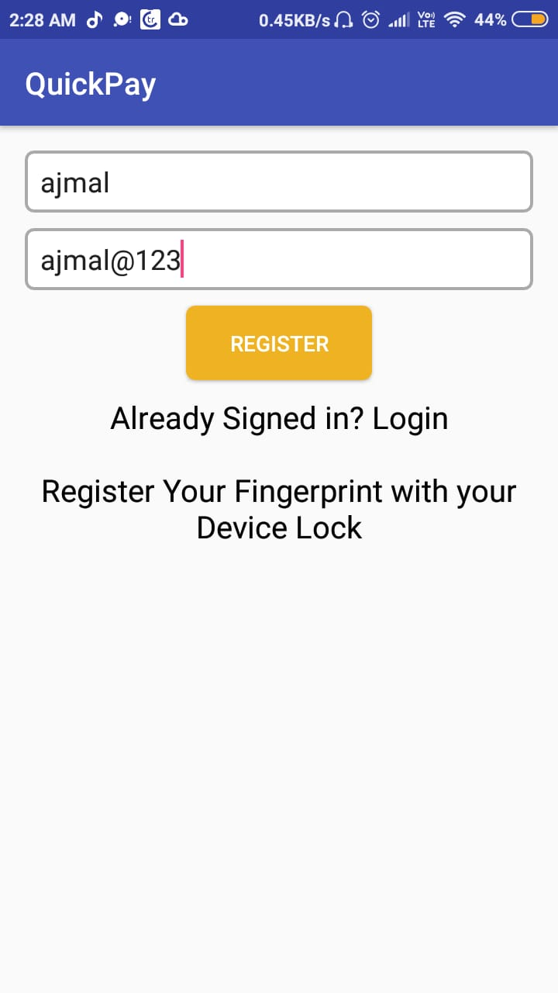 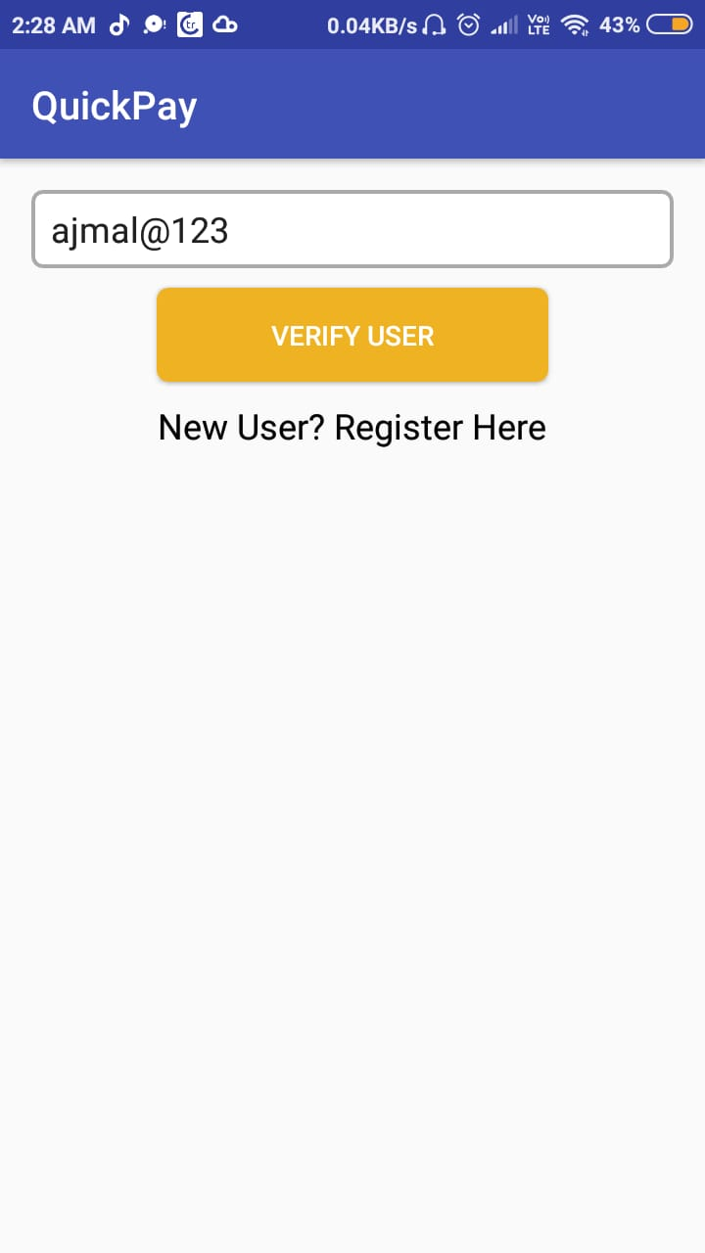

**FIG-15 REGISTER FIG-16 VERIFY USER**

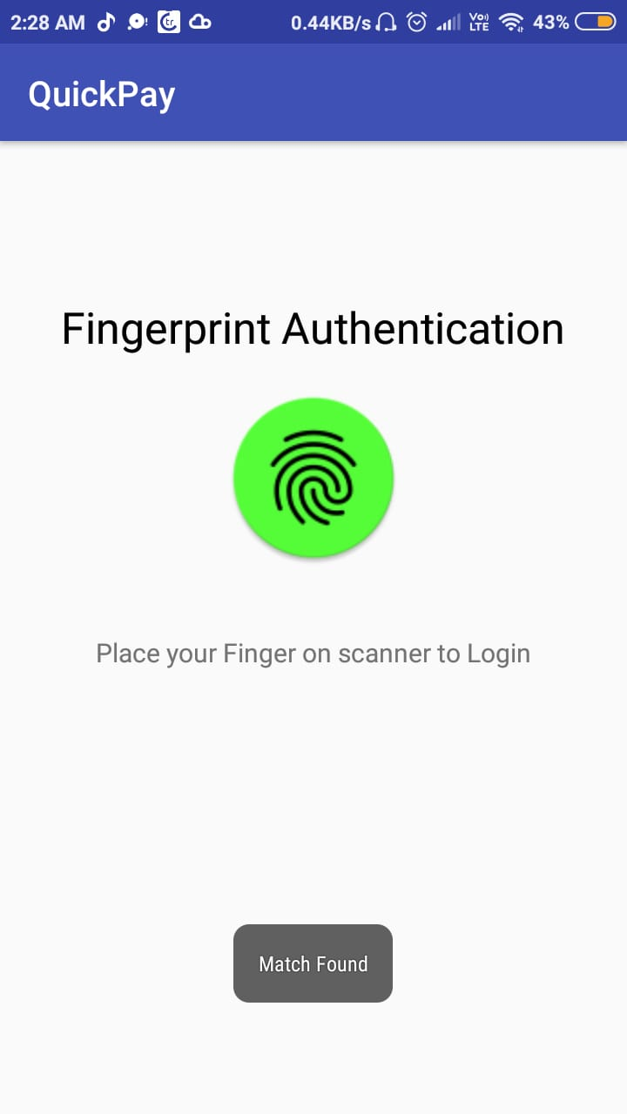 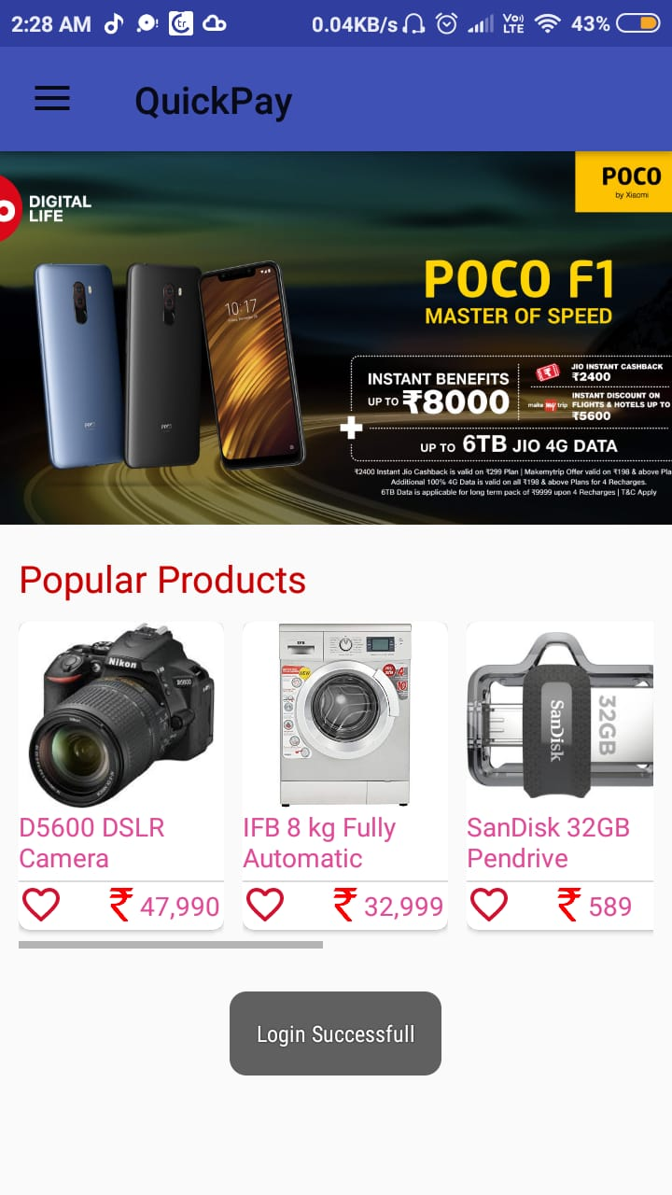

**FIG-17 FINGERPRITN FIG-18 HOME ACTIVITY**

**AUTHENTICATION**

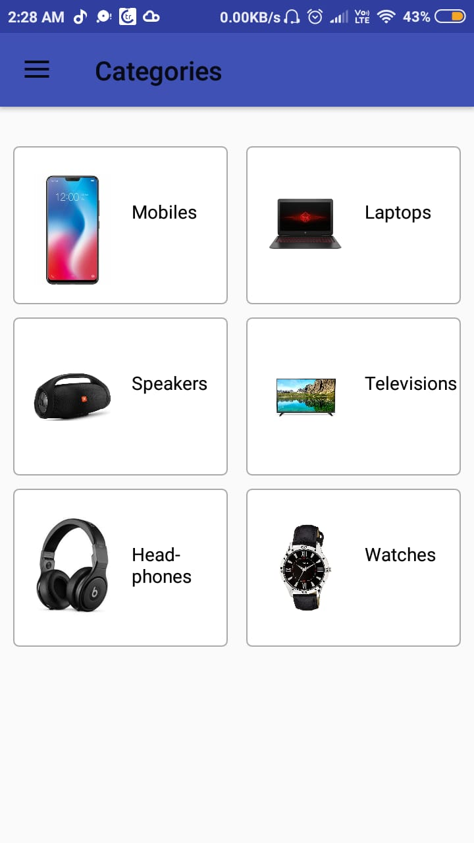 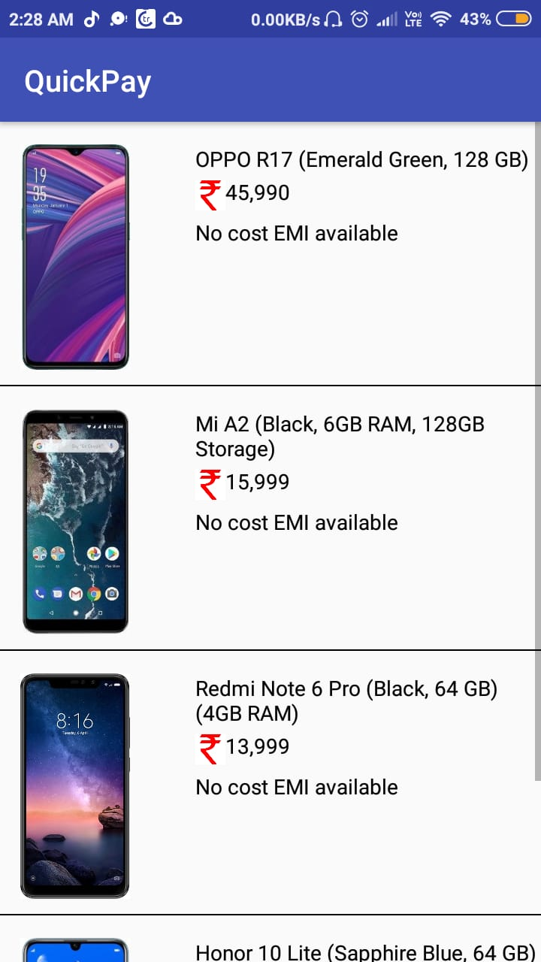

**FIG-19 CATEGORIES FIG-20 MOBILE CATEGORIES**

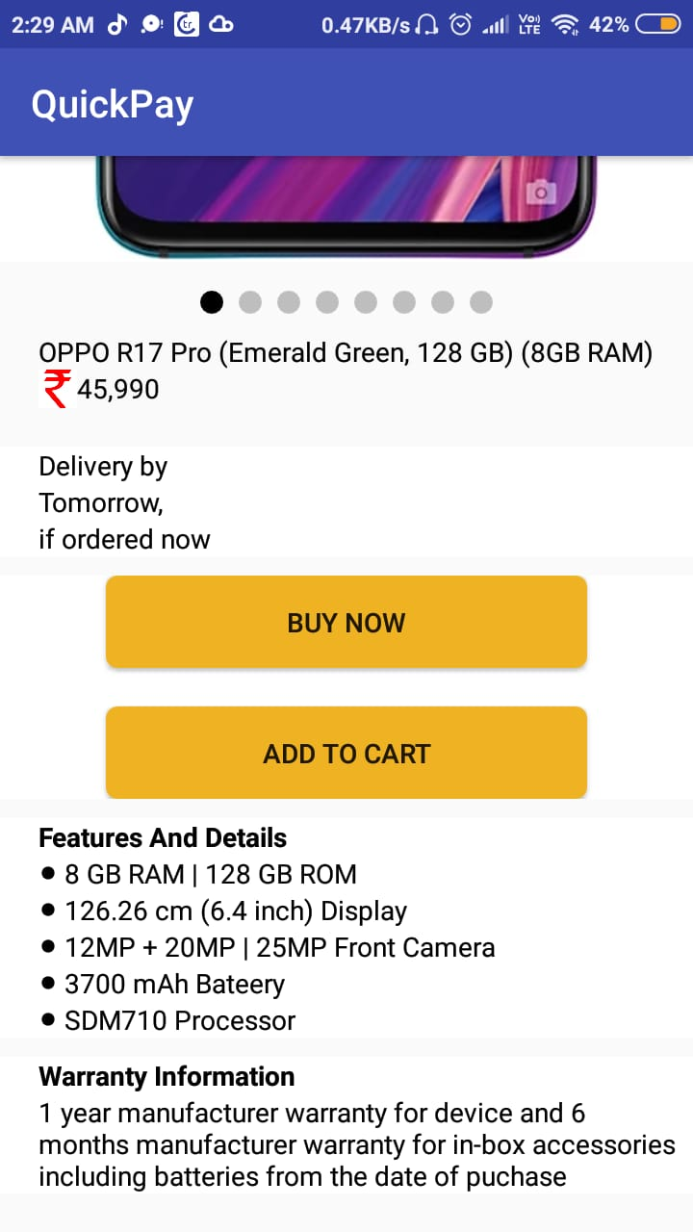 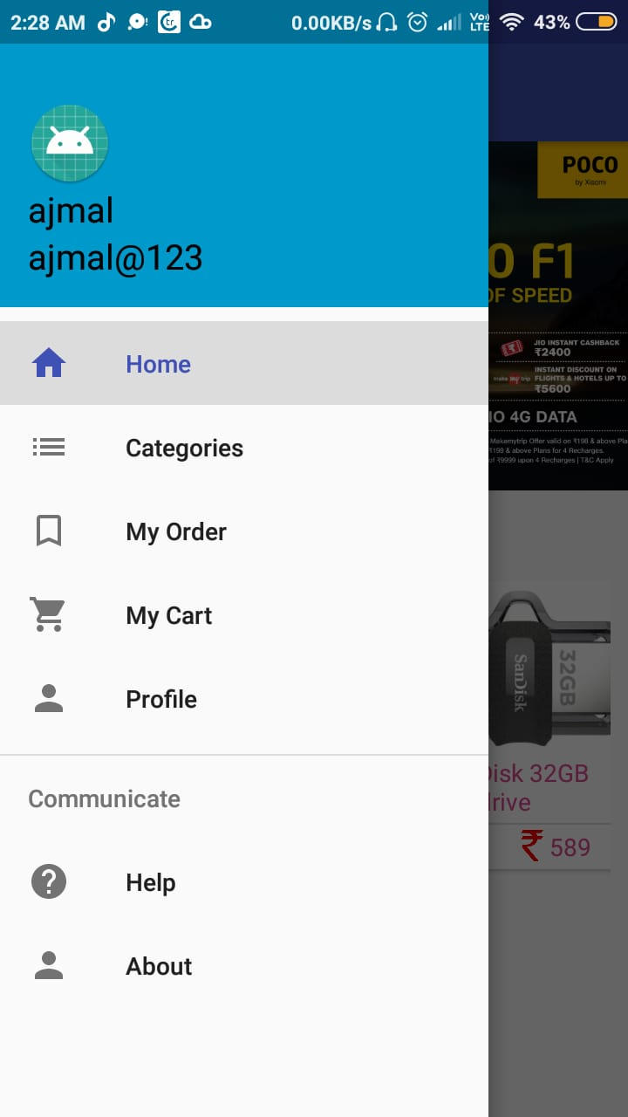

**FIG-21 PRODUCT DETAILS FIG-22 FRAGMENTS**

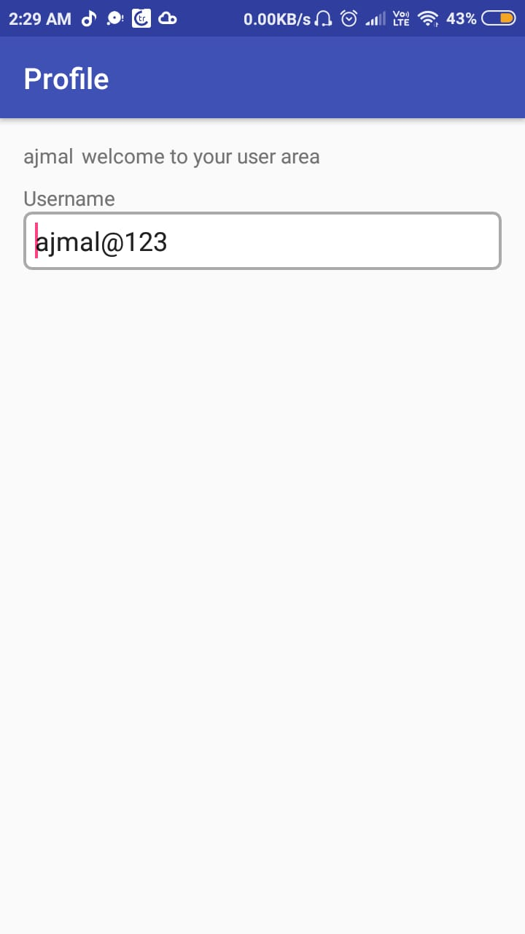 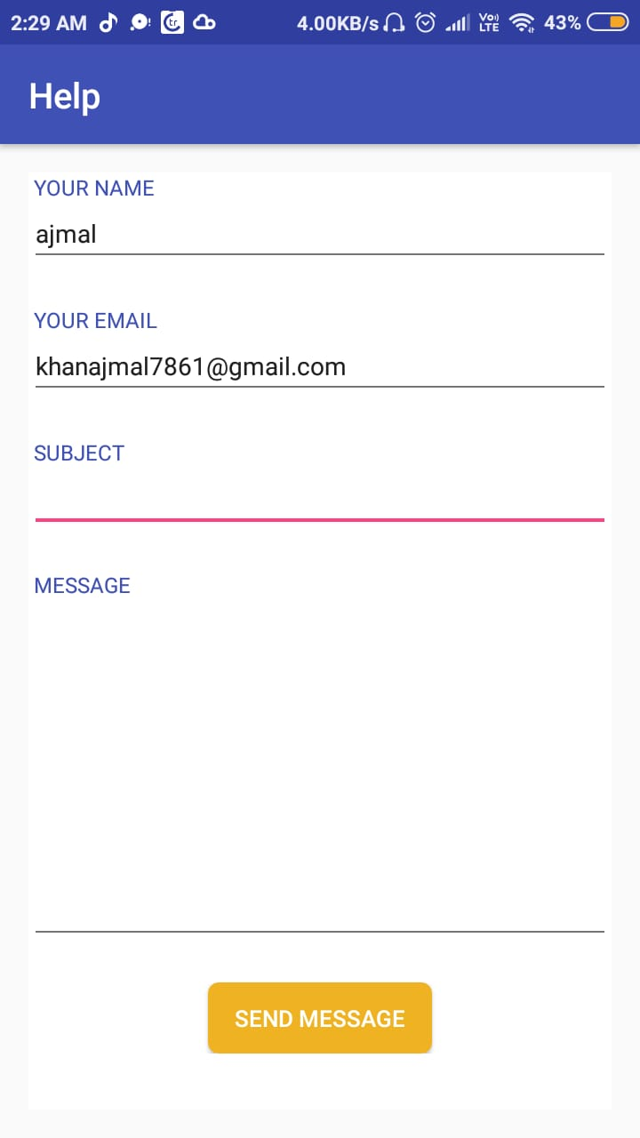

FIG-23 PROFILE FIG-24 CONTACT

Chapter 7

Testing

1. **Testing**

**7.1 Black Box Testing**

BLACK BOX TESTING, also known as Behavioral Testing is a software testing method in which the internal structure/design/implementation of the item being tested is not known to the tester. These tests can be functional or non-functional, though usually functional.

**Tester Assignment :**

|  |  |
| --- | --- |
| **Tester Name** | **Task** |
| Ajmal | Configuration, Compatibility |
| Atul | Layout : para ,bullet |
| Anagha | Character formatting : Size, Style, Colour, Font |
| Sneha | Stress and Load |
| Fiza | UI : Usability, Appearance |

How we tested our Application :

1. For Registration Process :

We have tested the registration module with the help of **positive testing** by entering random valid input data to check whether it behave as expected or not

Again for this module this time we tested with he help of negative testing by entering invalid input data to check if the system showing error when supposed to and not showing error when not supposed to.

1. For Purchasing products :

We entered random values and ensure that the data is stored in the database.

* 1. **Unit Testing**

Unit Testing is a level of software testing where individual units/ components of a software are tested. The purpose is to validate that each unit of the software performs as designed. A unit is the smallest testable part of any software. It usually has one or a few inputs and usually a single output.

We tested following module individually and check whether it behaves as expected :

* Registration process
* Login verification
* Fingerprint Authentication
* Product placement
* Profile Visible
* Contact

Chapter 8

Conclusion

# Conclusion

* The fingerprint authentication encourage users belong to data security.
* Rather than waiting for OTP and username, password fingerprint is easiest way for login.
* You may forget the password but fingerprint cannot as it is an biometric.
* Through our project you will came to know the proper use of fingerprint sensor.

Chapter 9

Future Scope

1. **Future Scope**

Biometric verification is gaining a lot of popularity among the public security systems as well as in the commercial market. In our Daily life, we witness the use of biometric in so many places such as the digital attendance system at offices, security checkpoints at air pots, wearable tech gadgets retrieving our biological information, and even our national ID cards Aadhaar cards are created using biometrics technology

In fact, this national ID program holds the largest biometric database in the world.

This will be more secure than existing system of Registration and Login process and it is more trustworthy.

Chapter 10

Bibliography and References

# 10. Bibliography and References

For, making project various reference where used .below are some websites which are used in project development

**[1] https://www.androidauthority.com/how-to-add-fingerprint-authentication-to-your-android-app-747304/**

**[2]** [**https://github.com/multidots/android-fingerprint-authentication**](https://github.com/multidots/android-fingerprint-authentication)

**[3]** [**https://www.androidhive.info/2016/11/android-add-fingerprint-authentication/**](https://www.androidhive.info/2016/11/android-add-fingerprint-authentication/)

**[4]** [**https://youtu.be/0NFwF7L-YA8**](https://youtu.be/0NFwF7L-YA8)

**[5] https://youtu.be/QxffHgiJ64M**